**Integration of JFrog with Jenkins**

1. Go to Jenkins , go to manage Jenkins->manage plugins -> available and search for artifactory plugin and then install it

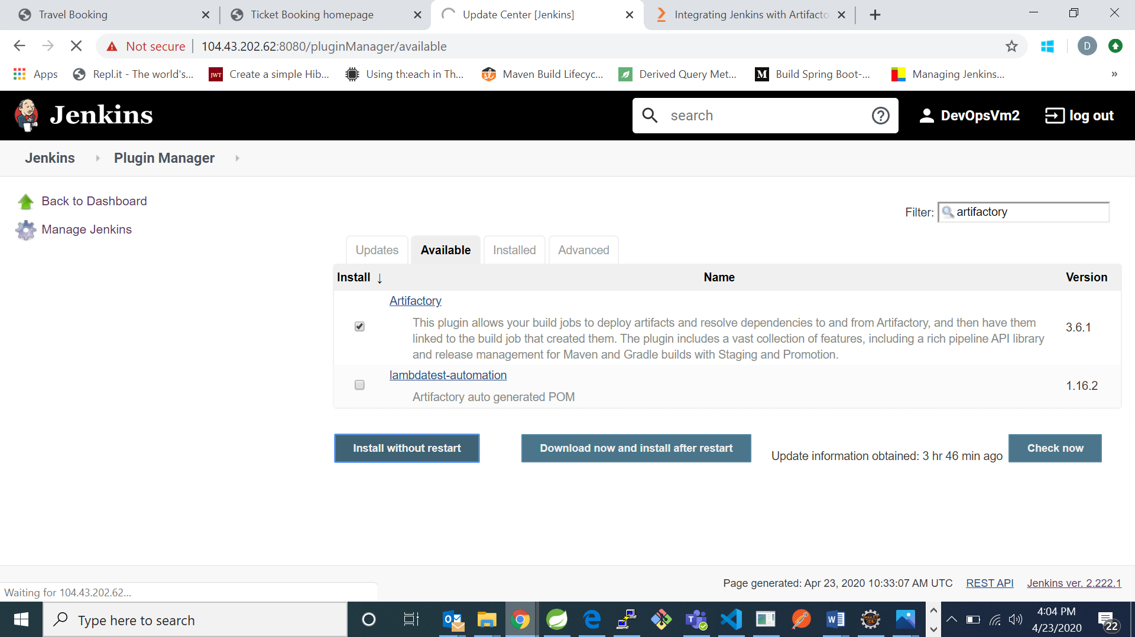

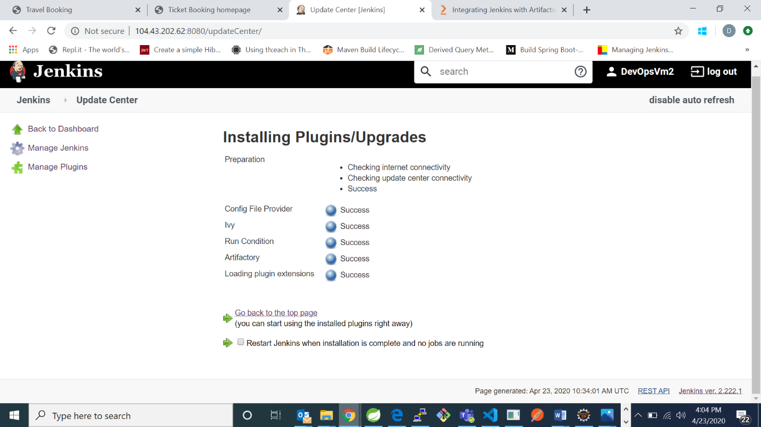

1. Now create a maven project by going to new item

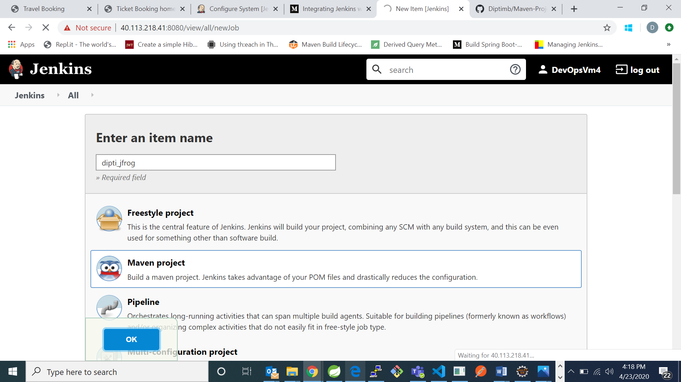

1. Go to Source Code Management and provide your github repository url

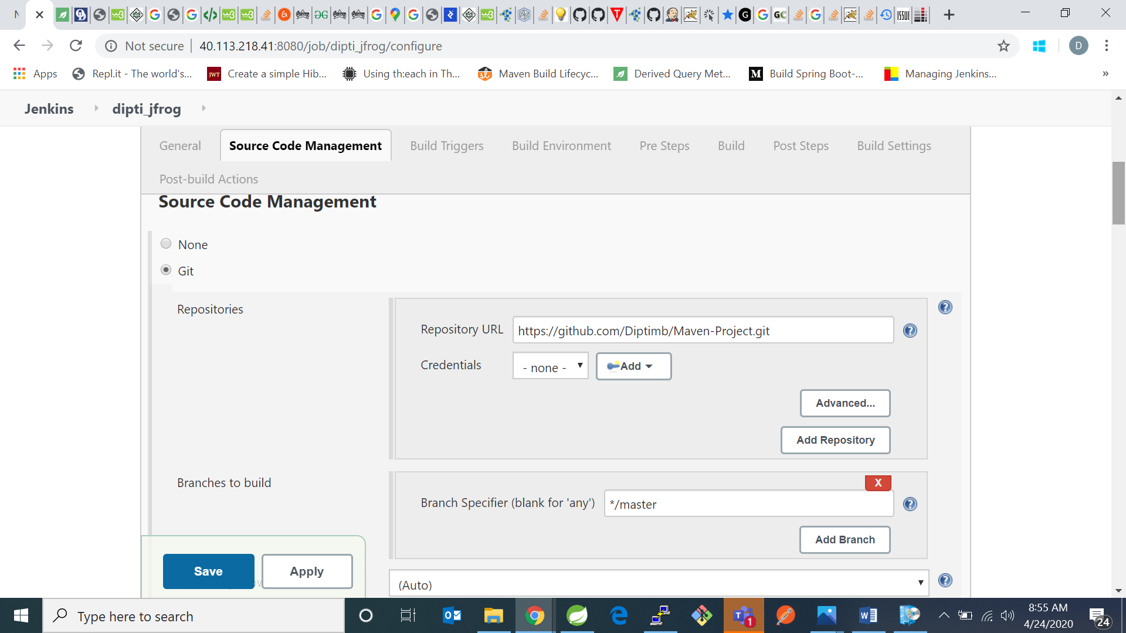

1. Goto Build environment and check “release artifacts from artifactory”
2. Click on refresh repositories and select libs-snapshot from select menu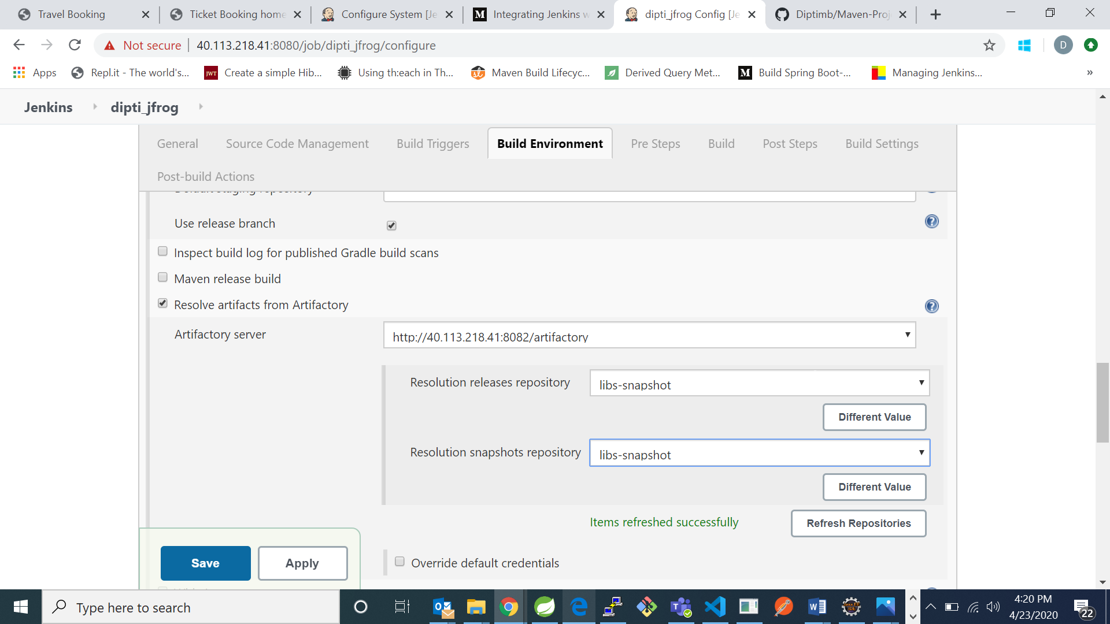
3. Check on artifactory release management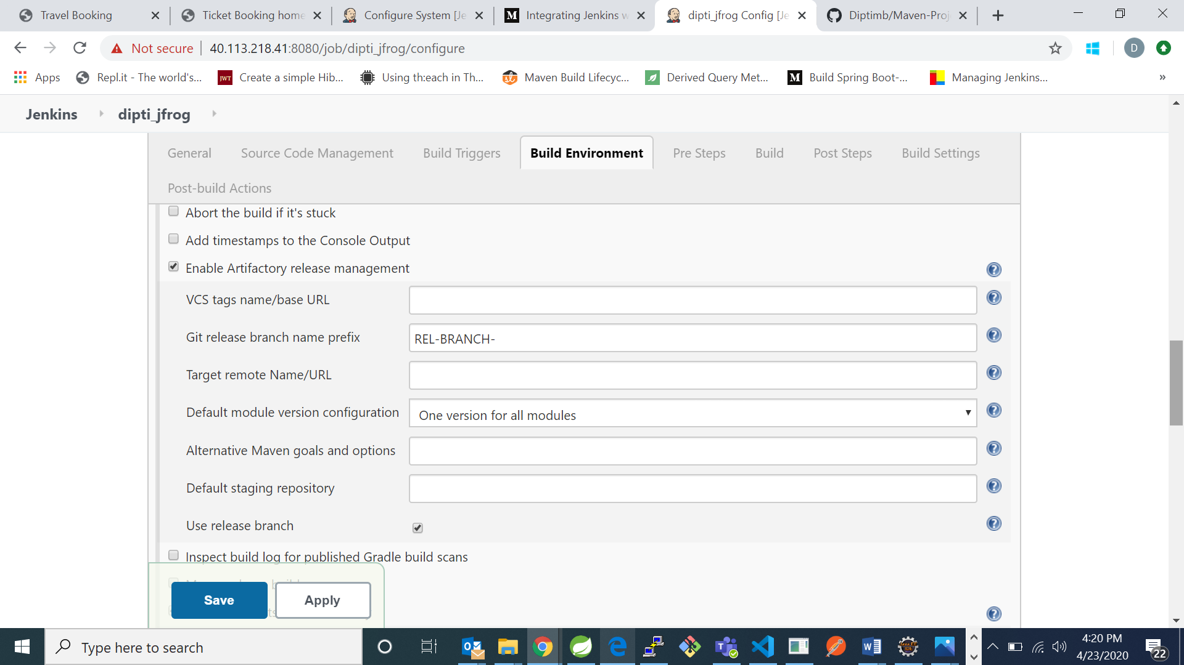
4. Go to build and in goals enter clean and install

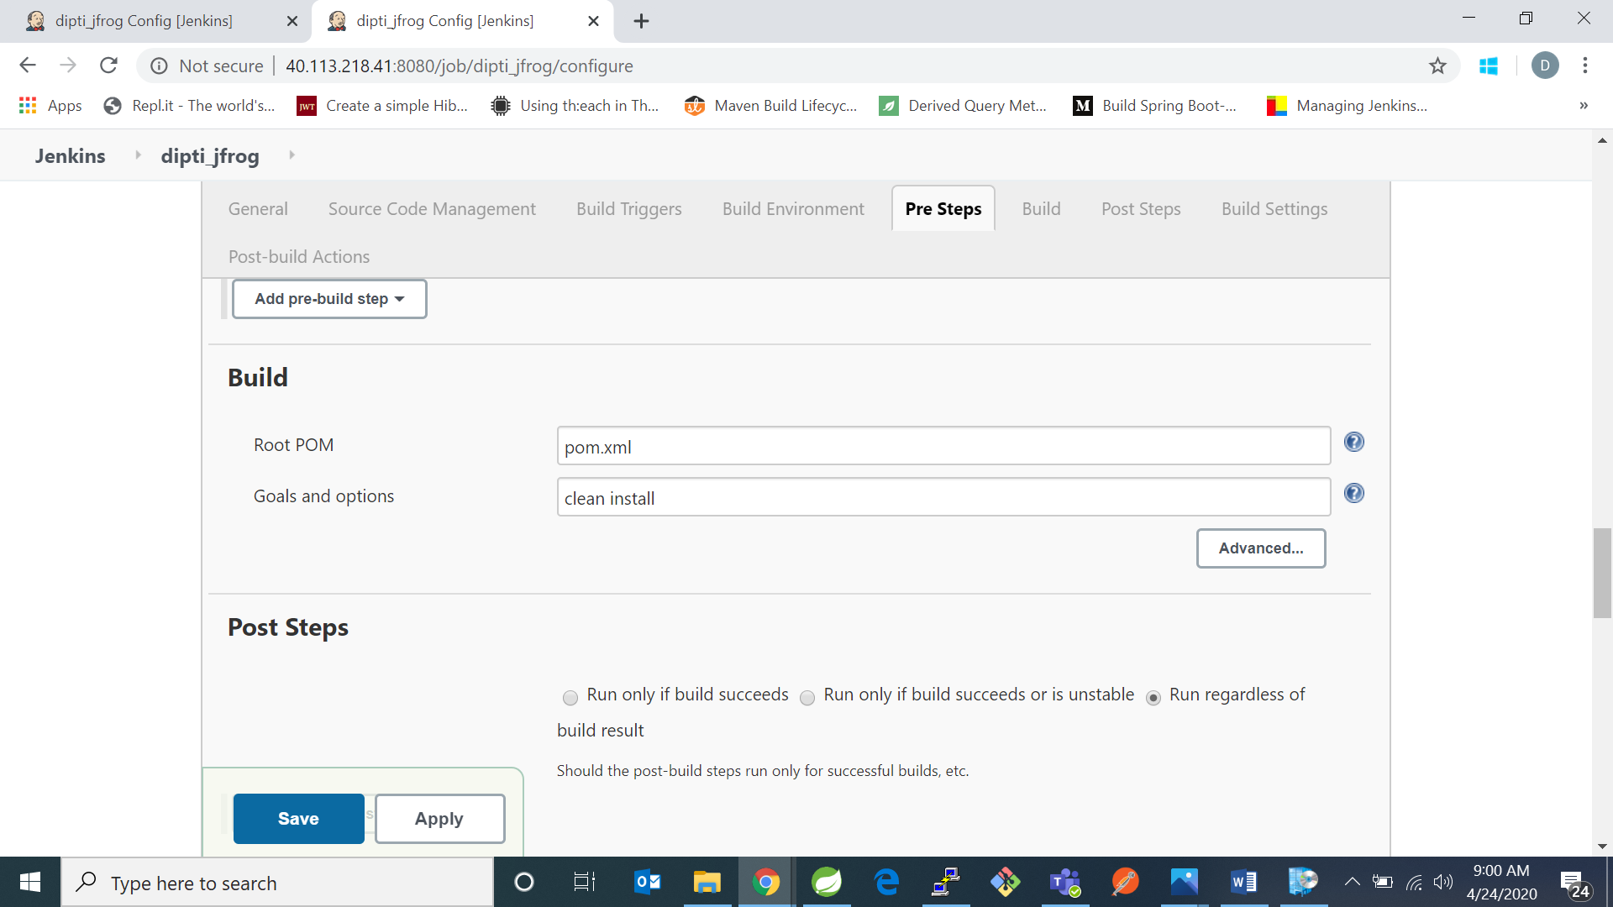

1. Then go to Post-build actions and select default artifacts from artifactory 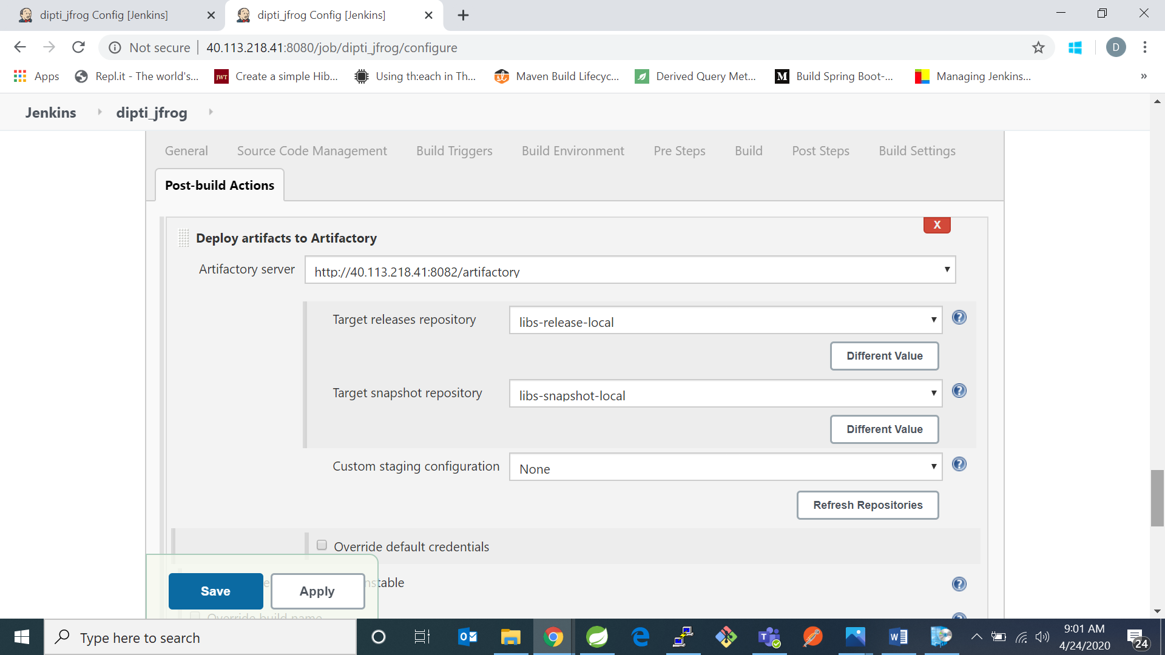
2. For target releases repository select libs-release-local and for target snapshot repository select libs-snapshot-local and click on save then

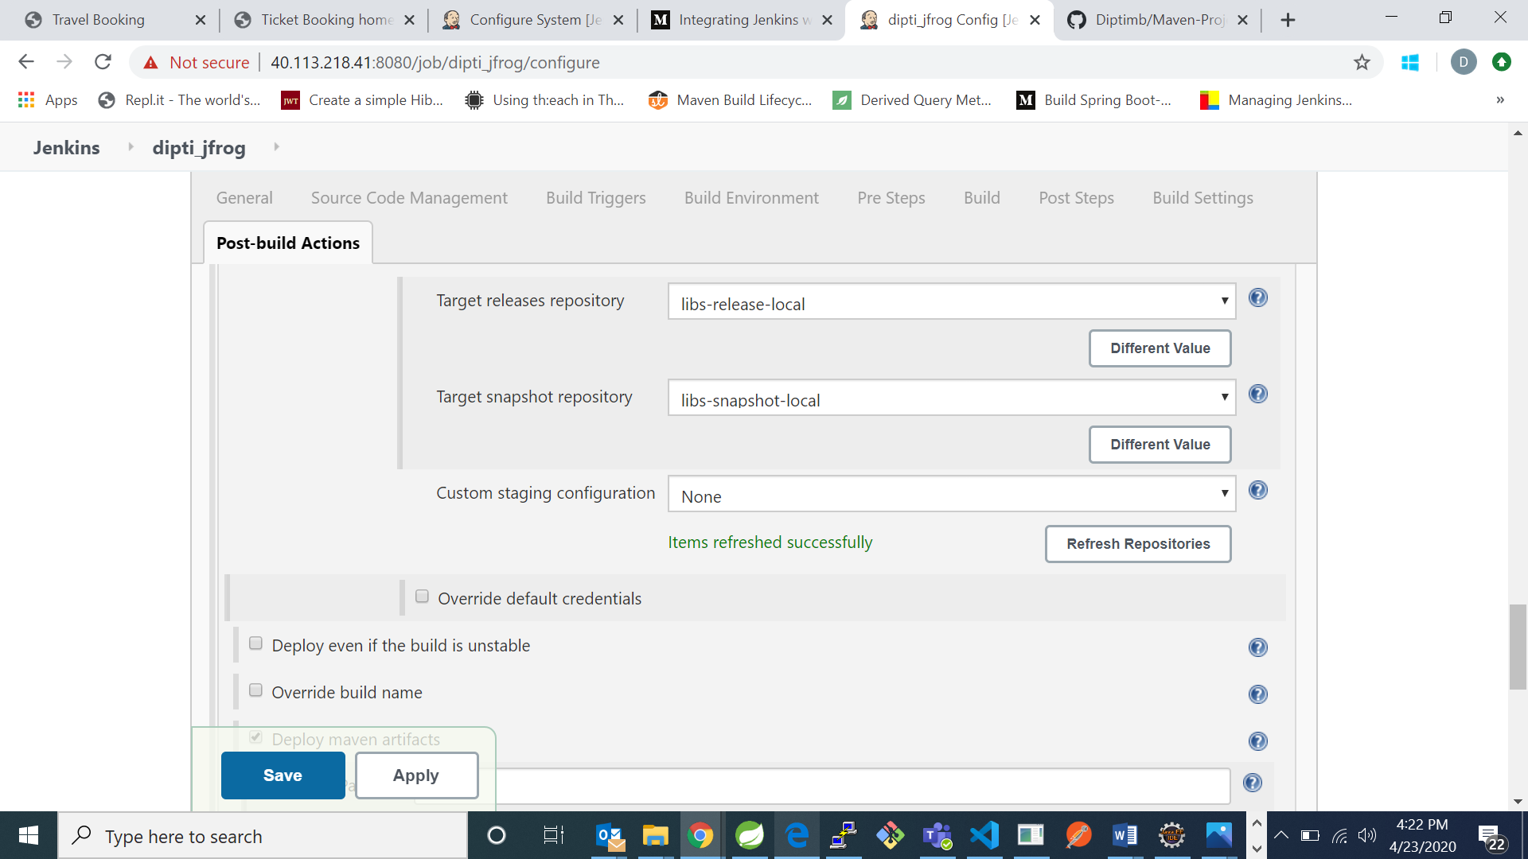

1. Now click on build and check for build status. 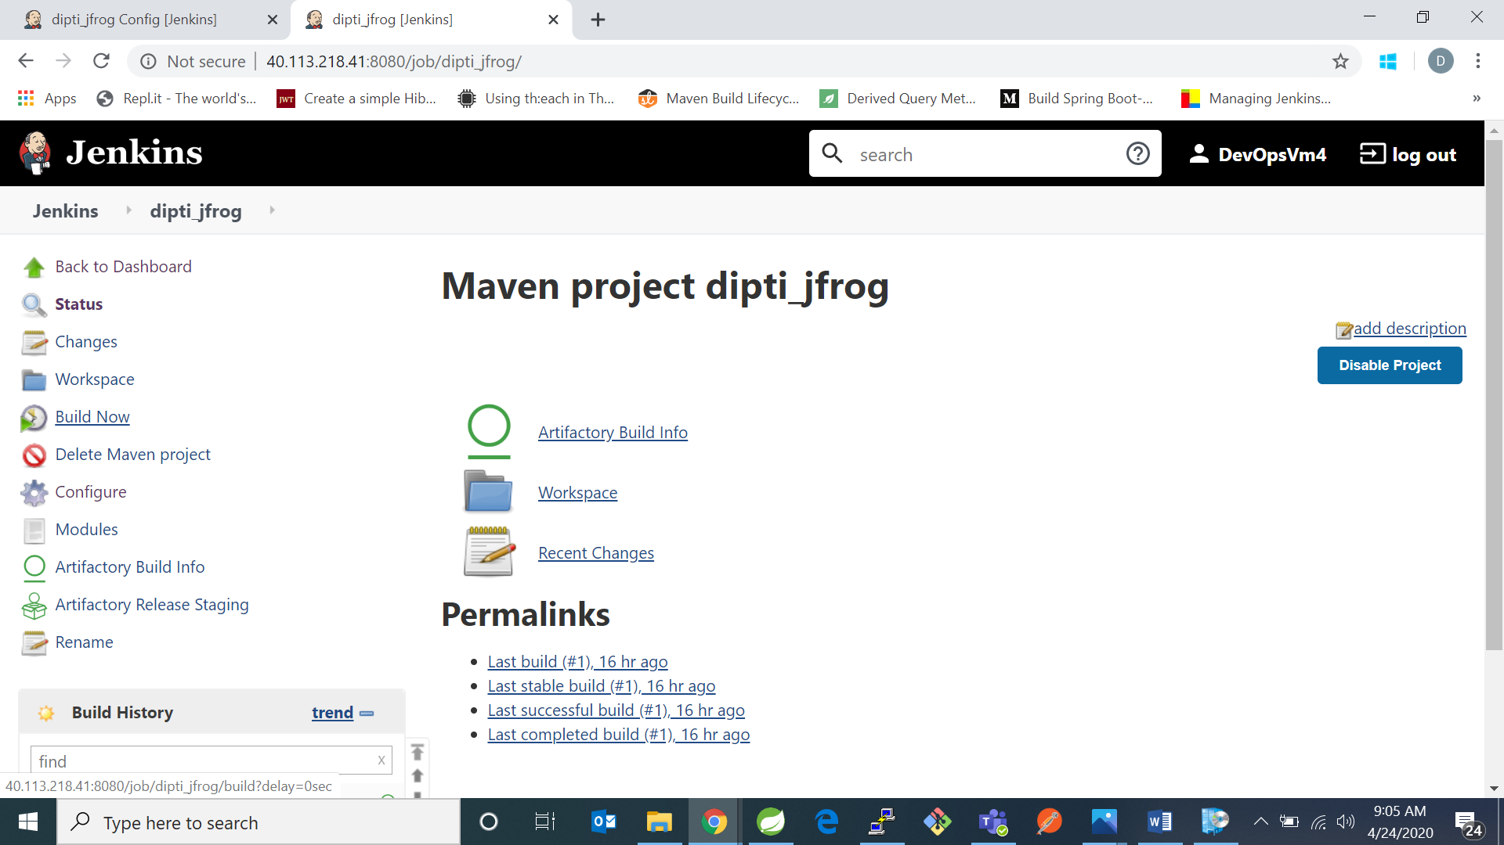

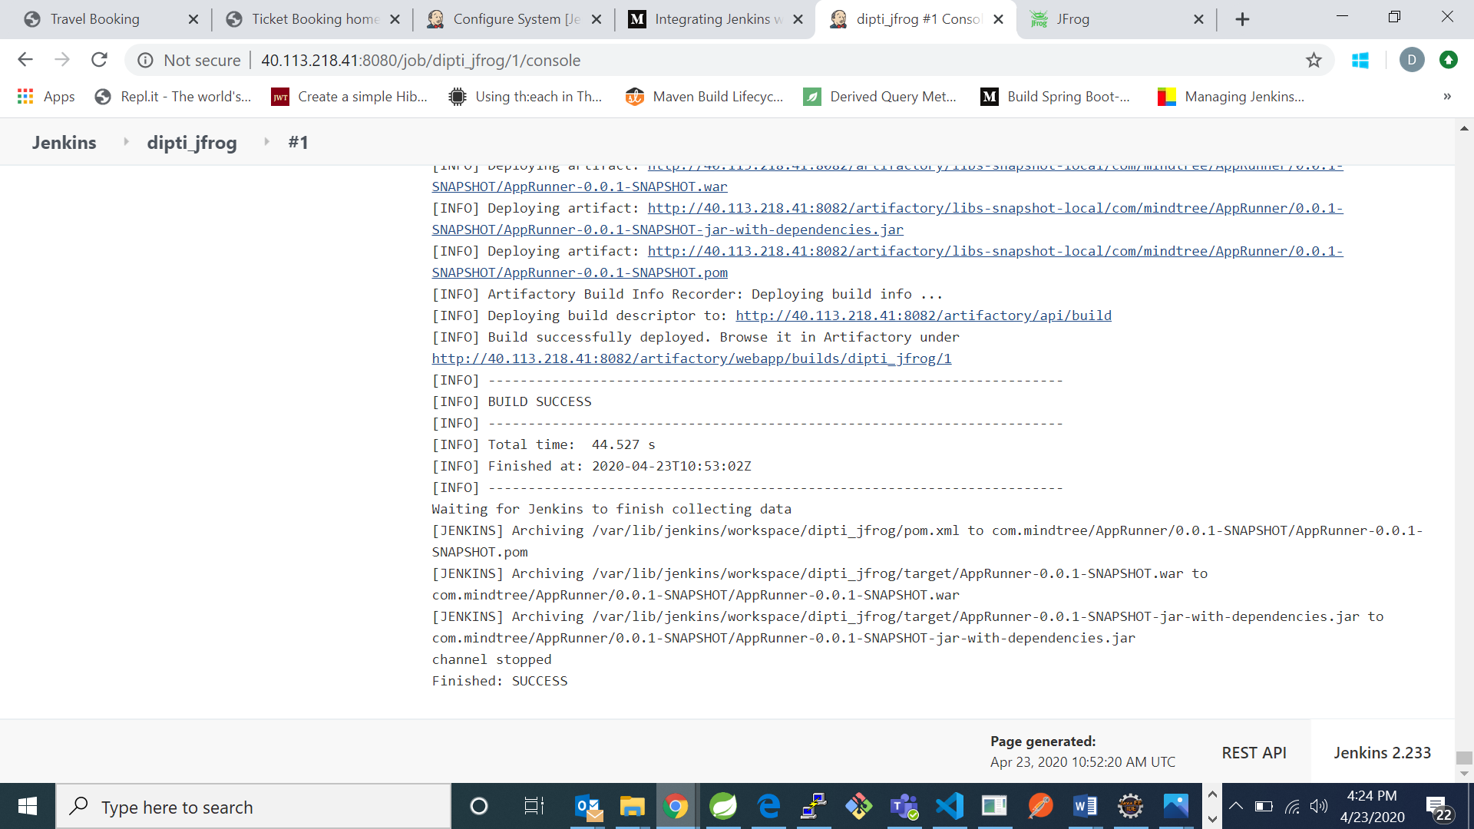

1. Now go to jfrog artifactory and check if your project is there in your artifactory or not. My project name was dipti_jfrog and I can see it is in the artifactory.
2. In jfrog go to builds and check for your project.